**AIM:** To create a hobby app page.

**PROCEDURE:**

1.To create required layouts.

2.To add the required texts.

3.Selecting the appropriate colors,fonts and font sizes.

4.To connect the texts with the appropriate layouts with the help of prototype.

5.Adding images wherever needed.

6.Finally watching the preview with the desktop view.

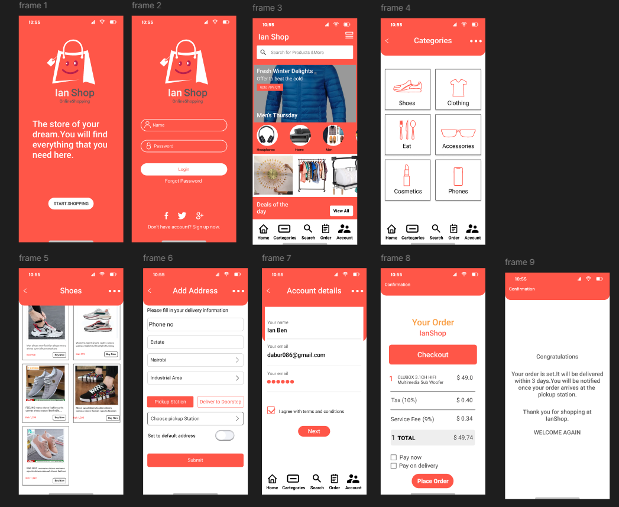

**RESULT:** Hence the design is completed and output is verified.